**MVJ College of Engineering, Bengaluru**

**(An Autonomous Institute)**

Affiliated to VTU, Belagavi, Approved by AICTE, New Delhi,

Recognized by UGC with 12(f) & 12(B), Accredited by NBA & NAAC



**REVIVE ALERT SYSTEM**

Submitted in partial fulfillment of requirements for the award of 8th semester,

**BACHELOR OF ENGINEERING**

**IN**

**INFORMATION SCIENCE AND ENGINEERING**

Submitted By:

**UDAY RANGANATH D (1MJ19IS098)**

**S ASHWIN (1MJ20IS081)**

**SHANKAR T (1MJ20IS089)**

**SIDDHARTHA LM (1MJ20IS095)**

Under the Guidance of

**Dr. JASNA S B**

Assistant Professor, Department of Information Science and Engineering

**DEPARTMENT OF INFORMATION SCIENCE AND ENGINEERING**

**MVJ COLLEGE OF ENGINEERING**

**BANGALORE-67**

**ACADEMIC YEAR 2023-24**



**MVJ COLLEGE OF ENGINEERING**

**BENGALURU-560067**

**(Autonomous Institution Affiliated to VTU, Belagavi)**

**DEPARTMENT OF INFORMATION SCIENCE AND ENGINEERING**

**CERTIFICATE**

Certified that the project work titled ***‘Revive Alert System’*** is carried out by **UDAY RANGANATH D (1MJ19IS098), S ASHWIN (1MJ20IS081), SHANKAR T (1MJ20IS089),** and **SIDDHARTHA L M(1MJ20IS095)** who are bonafide students of MVJ College of Engineering, Bengaluru, in partial fulfilment for the award of Degree of **Bachelor of Engineering in Information Science and Engineering** of the Visvesvaraya Technological University, Belagavi during the year 2023-2024. It is certified that all corrections/suggestions indicated for the Internal Assessment have been incorporated in the project report deposited in the departmental library. The project report has been approved as it satisfies the academic requirements in respect of project work prescribed by the institution for the said Degree.

**Signature of Guide Signature of HoD Signature of Principal**

**Dr. Jasna SB Dr. Jaya Chandwani Dr. Suresh Babu V**

**External Viva**

**Name of Examiners Signature with Date**

**1**

**2**

**MVJ COLLEGE OF ENGINEERING**

**BENGALURU-560067**

**(Autonomous Institution Affiliated to VTU, Belagavi)**

**DEPARTMENT OF INFORMATION SCIENCE AND ENGINEERING**

**DECLARATION**

**We, UDAY RANGANATH D, S ASHWIN, SHANKAR T** and **SIDDHARTHA L M,** students of eighth semester B.E., Department of Information Science & Engineering, MVJ College of Engineering, Bengaluru, hereby declare that the major project titled ***‘REVIVE ALERT SYSTEM’*** has been carried out by us and submitted in partial fulfilment for the award of Degree of **Bachelor of Engineering** in **Information Science & Engineering** during the year 2023-2024.

Further we declare that the content of the dissertation has not been submitted previously by anybody for the award of any Degree or Diploma to any other University.

We also declare that any Intellectual Property Rights generated out of this project carried out at MVJCE will be the property of MVJ College of Engineering, Bengaluru and we will be one of the authors of the same.

Place: Bengaluru

Date:

**Name**  **Signature**

1. **UDAY RANGANATH D (1MJ19IS098)**
2. **S ASHWN (1MJ20IS081)**
3. **SHANKAR T (1MJ20IS089)**
4. **SIDDHARTHA L M (1MJ20IS095)**

**ACKNOWLEDGMENT**

The satisfaction and euphoria that accompany the successful completion of a task would be incomplete without mention of people who made it possible. So, with gratitude we acknowledge all those who have guided and encouraged us as a beacon of light and crowned my effort with success.

We take this opportunity to convey our gratitude to the **Management of MVJ College of Engineering**, Bengaluru for providing excellent facilities and academic ambience making us feel proud to be a part of this esteemed institution.

We are extremely happy to submit our sincere thanks to **Dr.** **Suresh Babu V**, Principal, MVJ College of Engineering, Bengaluru, for being a constant inspiration and providing all the facilities that was needed throughout the project work.

We would like to express our gratitude to **Dr. M Brindha,** Vice Principal, MVJ College of Engineering, Bengaluru, for the constant encouragement throughout the course.

We like to express our gratitude to **COE Prof. Kumar R**, Controller of Examinations, MVJ College of Engineering, Bengaluru, for the guidance & suggestions to complete the project work.

We are thankful to **Dr. Jaya Chandwani**, HOD, Department of ISE, MVJ College of Engineering, Bengaluru, for her valuable support and guidance in completing the project.

We express our sincere and grateful credit to our guide **Dr. Jasna SB,** Department of Information Science Engineering, MVJ College of Engineering, Bengaluru, for her constant support and guidance. Her valuable suggestion & constant motivation helped us to successfully complete our project.

We would like to thank all Professors and staff at the Department of Information Science, MVJ College of Engineering, Bengaluru for their kind help and co-operation throughout the course.

We sincerely thank our parents, friends and seniors for giving us the moral support for the successful completion of the project work.

**Uday Ranganath D (1MJ19IS098)**

**S Ashwin (1MJ20IS081)**

**Shankar T (1MJ20IS089)**

**Siddhartha L M (1MJ20IS095)**

**ABSTRACT**

This research endeavours to address the escalating challenge of road accidents stemming from driver fatigue. The proposed solution leverages state-of-the-art computer vision techniques, specifically employing the YOLO (You Only Look Once) model—a convolutional neural network designed for object detection. Through meticulous data collection and preprocessing, our study focuses on creating a robust dataset, capturing diverse scenarios, and lighting conditions. The core of our approach involves training the deep learning model to discern facial cues indicative of driver drowsiness. Real-time analysis of live webcam imagery allows for prompt identification, with an integrated alert mechanism promptly notifying the driver. The comprehensive evaluation of the system's performance, including precision, recall, underscores its potential impact on mitigating road accidents caused by impaired driver attentiveness. This research marks a significant stride towards enhancing road safety through the synergy of computer vision and deep learning methodologies. The core of our approach lies in the training of the YOLO model on the prepared dataset. The model is fine-tuned and optimized, balancing hyperparameters to ensure high precision and recall rates. By employing a live webcam feed, the system analyses facial features in real-time, swiftly identifying signs of drowsiness with exceptional accuracy. To enhance the practicality and effectiveness of our system, an integrated alert mechanism, in the form of a buzzer or alarm, is activated upon detecting drowsy behaviour. This real-time response aims to proactively mitigate potential accidents caused by impaired driver attentiveness.

**ACRONYMS**

|  |  |
| --- | --- |
| **Acronym** | **Abbreviation** |
| USN | University Seat Number |
| SEM | Semester |
| YOLO | You Only Look Once |
| CNN | Convolutional Neural Networks |

**TABLE OF CONTENTS**

**Page No**

**Certificate I**

**Declaration II**

**Acknowledgement III**

**Abstract IV**

**Acronyms V**

**List of Figures**

**2**

3

3

4

5

**7**

**11**

13

14

**16**

16

16

**Chapter 1**

1. **Introduction** 
   1. Aim
   2. Motivation
   3. Objectives
   4. Organization of Chapters

**Chapter 2**

1. **Literature Survey**

**Chapter 3**

1. **Technical Concepts**
   1. Flowchart
   2. Algorithm

**Chapter 4**

1. **Objective and Methodology**
   1. Objective
   2. Methodology

**Chapter 5**

1. **Existing and Proposed System** 
   1. Existing System

**18**

19

20

21

**23**

**27**

27

27

28

28

**30**

**32**

* 1. Proposed System
  2. Comparison
  3. System Architecture

**Chapter 6**

1. **Results**

**Chapter 7**

1. **Requirements**
   1. Functional Requirements
   2. Non-Functional Requirements
   3. Software Requirements
   4. Hardware Requirements
2. **Conclusion**
3. **References**

**List of Figures**

**Figure No. Figure Title Page No.**

3.1 Flowchart 13

5.1 Comparison 20

5.2 System Architecture 21

6.1 P 1 Awake 23

6.2 P 1 Drowsy 23

6.3 P 2 Awake 23

6.4 P 2 Drowsy 23

6.5 P 3 Awake 24

6.6 P 3 Drowsy 24

6.7 P 4 Awake 24

6.8 P 4 Drowsy 24

6.9 Confidence Curve 25

6.10 Confusion Matrix 25

***CHAPTER-1***

***INTRODUCTION***

**CHAPTER 1**

**INTRODUCTION**

Ensuring driver safety remains a paramount concern on today's roads, with drowsiness posing a significant and potentially life-threatening threat. The adverse effects of fatigue on a driver's cognitive abilities, including reduced focus, delayed reactions, and impaired decision-making, significantly elevate the risk of accidents. In response to this pressing issue, advanced technologies rooted in computer vision and deep learning, exemplified by models such as YOLO (You Only Look Once), have emerged as robust solutions. This paradigm shift towards technological intervention aims to detect and address signs of drowsiness in real-time, utilizing in-vehicle cameras as the primary sensory input. The integration of computer vision techniques, coupled with the YOLO model's capabilities, presents a transformative approach to mitigating the risks associated with drowsy driving. By harnessing the power of artificial intelligence, this innovative system goes beyond traditional safety measures, offering a proactive means of monitoring and responding to a driver's state in real-time. At the heart of this technological advancement is the ability to capture and interpret crucial facial expressions, eye movements, and behavioral cues through the lens of an in-vehicle camera.

* 1. **AIM**

The primary aim of our project is to revolutionize driver safety by developing and implementing a sophisticated system that leverages computer vision and deep learning, specifically the YOLO (You Only Look Once) model. Our focus is on real-time detection of drowsiness in drivers, a critical factor contributing to road accidents. By deploying in-vehicle cameras and advanced artificial intelligence, we aim to create a proactive safety mechanism capable of monitoring and responding to a driver's state instantly.

* 1. **MOTIVATION**

The motivation behind this project stems from the urgent need to address the escalating risks associated with drowsy driving. Despite heightened awareness of the dangers, accidents caused by driver fatigue persist as a significant threat on our roads. We are driven by a commitment to significantly reduce accidents and save lives by intervening precisely when a driver's alertness is compromised. The incorporation of real-time data analysis enables us to go beyond conventional safety measures, offering timely alerts and interventions.

* 1. **OBJECTIVES**

The main objective of this project is to plan a system to distinguish driver’s sluggishness and drowsiness by persistently checking the facial expressions of the driver by facial detection concept and alerting the driver through an alarm system, thus ensuring road safety. This facial detection concept is achieved using the YOLOv8 (You Only Look Once) algorithm.

The objective of this project is to:

* Capture the driver’s facial image through a camera using OpenCV.
* Analyse the obtained image to identify the drowsiness of the driver.
* From the two different classes of awake and drowsy identify whether the driver is experiencing drowsiness from the obtained facial image using YOLOv8 (You Only Look Once) algorithm.
* If drowsiness detected, then alert the driver using alarm system
* Thus, the main objective is to ensure the driver’s safety and reduce road accidents

**1.4. ORGANIZATIONS OF CHAPTERS**

For proper presentation of work, the project is divided into seven chapters

The chapter one will cover the introduction which talks about the background of our project. The chapter one also sheds light on the aim and motivation towards our project and also covering the objectives. In this chapter the existing and proposed system is discussed in detail.

The chapter two deals with the literature survey, here we discuss about the base paper and nearly nine research paper to understand various factors related to our project.

The chapter three deals with hardware and software requirements for our projects, also this chapter covers functional and non-functional requirements related to our project.

***CHAPTER-2***

***LITERATURE SURVEY***

**CHAPTER 2**

**LITERATURE SURVEY**

The Small Size Object Detection Algorithm Based on Camera Sensor introduced by Haitong Lou, Xuehu Duan, Junmei Guo., [1]. This paper addresses the limitations of traditional camera sensors in detecting small-sized objects due to human eye fatigue and cognitive limitations. It proposes a small size target detection algorithm for special scenarios, incorporating a novel down-sampling method, improved feature fusion network, and a new network structure. The YOLOv8 version is chosen as the baseline for its extensibility and performance comparison benefits.

This paper provides Improved YOLOv8 for Remote Sensing Object Detection introduced by Tianyong Wu and Youkou Dong.,[2]. Focusing on remote sensing image analysis, this paper introduces YOLO-SE, a YOLOv8-based network designed to address challenges in detecting objects across diverse scales, particularly small-sized targets. The novel contributions include a lightweight convolution SE Conv, an Efficient Multi Scale Attention (EMA) mechanism, and a dedicated prediction head for tiny object detection.

This paper provides Real-Time Object Detection with Yolo introduced by Geethapriya. S, N. Duraimurugan, S.P. Chokkalingam.,[3]. This paper explores real-time object detection applications, comparing algorithms based on Classifications (CNN and RNN) and Regressions (YOLO). YOLO is highlighted for its efficiency, processing 45 frames per second, making it suitable for real-time systems like self-driving cars.

This paper provides Unified, Real-Time Object Detection introduced by Joseph Redmon.,[4]. Introducing YOLO, this paper reframes object detection as a regression problem, predicting bounding boxes and class probabilities directly from images in one evaluation. The unified architecture achieves real-time processing at 45 frames per second and outperforms other real-time detectors.

This paper provides A Review on Face Recognition Systems Built Using YOLO introduced by Manashri Gasti, Payal Das.,[5]. Investigating YOLO's application in face recognition, this paper explores the use of YOLO for face detection in real-time video and photos. It contrasts YOLO's approach with traditional methods, emphasizing its speed and efficiency in handling video streams.

This paper provides Enhancing Real-Time Object Detection with YOLO Algorithm introduced by Gudala Lavanya and Sagar Dhanraj Pande.,[6]. Providing an extensive understanding of the YOLO algorithm, this paper focuses on its architecture and impact on real-time object detection. YOLO is framed as a regression problem, detecting objects in one operation through the neural network, making it a crucial component of computer vision.

This paper provides YOLO Algorithm Accuracy Analysis in Detecting Number of Vehicles at the Intersection introduced by N Dewantoro, P N Fernando, Sofyan Tan.,[7]. Evaluating the effectiveness of the YOLO algorithm in detecting vehicles, this research uses both original and custom datasets. Results indicate YOLO's success in detecting vehicles, though some mislabeling occurs, demonstrating the algorithm's potential in traffic-related applications.

This paper provides Car Detection Using YOLO Algorithm introduced by Ajinkya Marode.,[8]. Focusing on the application of YOLO in car detection, this paper emphasizes the importance of object detection for autonomous cars. The model is trained for various classes and demonstrates the effectiveness of YOLO in different driving conditions.

This paper provides Driver Drowsiness Detection and Alert System introduced by Swapnil Titare, Shubham Chinchghare.,[9]. Addressing the increasing incidents of accidents due to driver drowsiness, this research aims to detect and alert drowsy drivers using webcam images. The project emphasizes the utilization of computer vision to enhance driving safety by monitoring the driver's state in real-time.

This paper provides Detecting Fatigue in Car Drivers and Aircraft Pilots by Using Non-Invasive Measures introduced by Xinyun Hu, Gabriel Lodewijks.,[10]. Focuses on detecting fatigue in drivers and pilots, this paper provides insights into non-invasive measures for differentiating sleepiness and mental fatigue. The study aims to improve research results for developing in-vehicle fatigue detection devices.

***CHAPTER-3***

***TECHNICAL CONCEPTS***

**CHAPTER 3**

**TECHNICAL CONCEPTS**

1. Single Shot Object Detection:

* You Only Look Once (YOLO): YOLO is a single-shot object detection system that divides an image into a grid and predicts bounding boxes and class probabilities for objects within each grid cell.

1. Network Architecture:

* Deep Convolutional Neural Network (CNN): This architecture allows the model to learn hierarchical features from input images, capturing complex patterns and representations.

1. YOLOv8 Architecture Enhancements:

* YOLOv8 Architecture: YOLOv8 introduces improvements over previous versions, enhancing the model's accuracy and speed.

1. Bounding Box Prediction:

* Grid Cells: The input image is divided into a grid. Each bounding box includes information about the object's coordinates (x, y, width, height).
* Class Prediction: YOLOv8 predicts class probabilities for each detected object within a grid cell.

1. Training Process:

* Anchors: Anchors are pre-defined boxes that help the model learn the correct scale and aspect ratio of objects.
* Loss Function: The model is trained using a combination of localization loss, confidence loss, and class loss.

1. Post-Processing:

* Non-Maximum Suppression (NMS): This step ensures that each object is represented by a single bounding box with the highest confidence score.

1. Alert Mechanism:

* Feedback to the Driver: This can include visual alerts on the dashboard, auditory alarms, or haptic feedback to grab the driver's attention and prompt them to stay alert.

### FLOWCHART

**Figure 3.1 FLOWCHART.**

* **Data Collection**: The process begins with collecting relevant data. In the context of driver drowsiness detection, this could involve capturing images or video frames from a camera mounted inside the vehicle.
* **Input Image**: The collected data serves as input for further analysis.
* **Image Segmentation**: The input image is divided into smaller segments or regions. This segmentation helps focus on specific areas of interest within the image.
* **Bounding Box Prediction**: Within each segmented region, the system predicts bounding boxes. These boxes outline potential objects or features, such as the driver’s eyes, mouth, or head position.
* **Class Prediction**: The identified bounding boxes are then classified into specific categories
* **Driver Drowsiness Prediction**: Based on the classification results, the system assesses whether the driver is drowsy. It may consider factors like eye closure duration, head position, and other relevant features.
* **Alarm the Driver**: If the system detects signs of drowsiness, it triggers an alarm. This could be an audible alert, vibration, or visual warning to prompt the driver to stay alert.

### ALGORITHM

YOLO is a deep learning model, specifically a neural network-based algorithm. It falls under the category of convolutional neural networks (CNNs), which are a type of deep learning architecture commonly used for image-related tasks. The YOLO algorithm is designed to perform object detection tasks, where the goal is to identify and locate objects within an image or a video frame. It uses a neural network to process the entire input image.

* Input Division:

YOLOv8 takes an input image and divides it into a grid of cells.

* Bounding Box Prediction:

For each grid cell, the algorithm predicts bounding boxes.

Each bounding box is defined by its centre coordinates (x, y), width (w), height (h), and a confidence score.

* Class Prediction:

Each bounding box predicts the probability distribution of different classes for the object it contains.

* Confidence Score:

The algorithm assigns a confidence score to each bounding box, indicating how likely it is that the box contains an object.

* Non-Maximum Suppression:

To eliminate redundant or overlapping predictions, YOLOv8 uses non-maximum suppression. This process removes boxes with low confidence scores or high overlap.

* Output:

The final output consists of the retained bounding boxes along with their class probabilities and confidence scores, representing the detected objects in the image.

***CHAPTER-4***

***OBJECTIVE AND METHODOLOGY***

**CHAPTER 4**

**OBJECTIVE AND METHODOLOGY**

* 1. **Objectives**

The primary goal of our project is to create a system that uses advanced computer vision, specifically the YOLOv8 model, to detect signs of drowsiness in drivers in real-time. By analyzing facial expressions and eye movements captured through a webcam inside the vehicle, the system aims to identify key indicators of drowsiness. We also consider optional features such as a user interface for real-time feedback and logging for further analysis. Ultimately, our aim is to enhance driver safety by providing timely interventions and insights into drowsy driving behavior, contributing to the reduction of accidents caused by driver fatigue.

* 1. **Methodology**

Our methodology involves several key steps to create an effective drowsiness detection system. First, we capture live images of the driver's face using a webcam installed in the vehicle. These images are then processed to ensure they're in the right format for our YOLOv8 model, a smart tool that's great at spotting things in pictures. The YOLOv8 model helps us identify important facial features and signs of drowsiness. We've also added a clever system to analyse this information and sound an alert, like a buzzer, when it thinks the driver might be getting too sleepy. Our step-by-step approach ensures a reliable and user-friendly solution for making driving safer by preventing accidents caused by drowsy driving.

***CHAPTER-5***

***EXISTING AND PROPOSED SYSTEM***

**CHAPTER 5**

**EXISTING AND PROPOSED SYSTEM**

### 5.1 Existing System

In the existing drowsiness detection system that utilizes physiological signals such as EOG (Electrooculogram), ECG (Electrocardiogram), EEG (Electroencephalogram), and HRV (Heart Rate Variability). The system detects changes in physiological parameters associated with drowsiness, such as decreased blood pressure, heart rate, and body temperature. The existing system employs SVM (Support Vector Machine) as a classification algorithm for drowsiness detection. EEG and ECG sensors can provide very accurate measurements of drowsiness, but they can also be affected by external factors that can affect their readings. EEG and ECG systems rely on sensors that measure brain and heart activity. In the existing system the drowsiness of the driver is detected using EAR (Ear Aspect Ratio) and MAR (Mouth Aspect Ratio). The calculations done by the EAR and MAR may be accurate but not as accurate as the prediction done by the YOLO algorithm in the proposed system. EAR and MAR systems use cameras to track changes in facial features. EAR and MAR systems can also be accurate, but they may be affected by things like changes in facial hair that obscure the eyes or mouth. In the existing system the facial landmarks are used to detect the drivers face and Identify eye closure of the driver by estimating the EAR value, a vehicle safety project that helps prevent accidents caused by the driver's sleep.

**5.2 Proposed System**

In this project we are proposing a driver drowsiness monitoring system with more accuracy and speed. The proposed system achieves the highest accuracy. In this model we have used YOLOV8 to train the dataset and after training we can use this model to detect and recognize whether the driver is experiencing drowsiness or not. YOLO has several advantages over other object detection algorithms. It is extremely fast, capable of processing images in real-time, making it suitable for applications that require quick responses. YOLO also has good generalization capabilities and can detect a wide variety of object classes. Anchor-free detection is when an object detection model directly predicts the center of an object instead of the offset from a known anchor box. Anchor boxes are a pre-defined set of boxes with specific heights and widths, used to detect object classes with the desired scale and aspect ratio. They are chosen based on the size of objects in the training dataset and are tiled across the image during detection. YOLOv8 is the latest version of YOLO by Ultralytics, introducing new features and improvements for enhanced performance. This versatility allows users to leverage YOLOv8's capabilities across diverse applications and domains.

**5.3 Comparison**

YOLOv8, with its deep learning architecture, can capture complex features and patterns in driver behavior, leading to more accurate drowsiness detection compared to EAR and MAR-based systems, which may struggle with variability in facial expressions and lighting conditions. YOLOv8 is more robust to variations in environmental factors such as lighting and occlusions, providing consistent performance across different driving conditions. In contrast, EAR and MAR may be sensitive to changes in lighting and facial occlusions, leading to false alarms or missed detections. YOLOv8 can process images rapidly, making it suitable for real-time applications like driver monitoring systems. On the other hand, EAR and MAR calculations may require more computational resources, potentially introducing delays in detection. YOLOv8 can detect multiple objects simultaneously, allowing for the detection of various signs of drowsiness beyond just eye and mouth movements, such as changes in head position or eyelid drooping, enhancing the overall effectiveness of the system.

**Figure 5.1 COMPARISON.**

**5.4 System Architecture**

**Figure 5.2 SYSTEM ARCHITECTURE**

* Webcam Capture: Captures live images from the webcam.
* Preprocessing Module: Resizes and normalizes images for YOLOv8, applies data augmentation.
* YOLOv8 Model: Object detection model for identifying regions of interest.
* Drowsiness Detection Logic: Analyses YOLOv8 output for drowsiness indicators.
* Alerting Mechanism: Triggers alerts (e.g., buzzer) based on detected drowsiness.
* Real-Time Processing: Ensures low-latency processing for real-time feedback.
* User Interface: Optional GUI for user interaction and system monitoring.

***CHAPTER-6***

***RESULTS***

**CHAPTER 6**

**RESULTS**

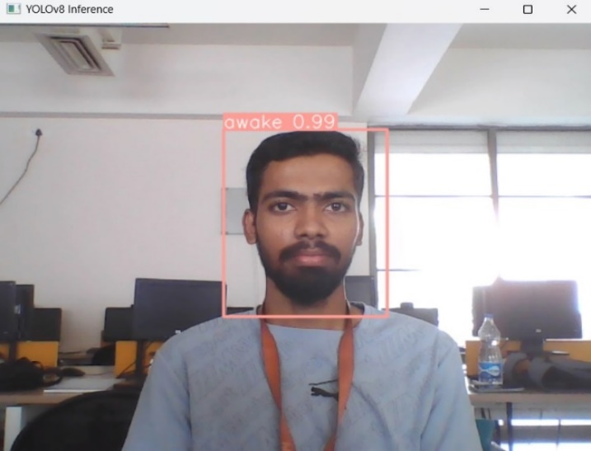

Fig 6.2 P 1 Drowsy.

Fig 6.1 P 1 Awake.

In the above figure 6.1 & 6.2 The system identifies Person 1 Awake in 6.1 and Drowsy in 6.2

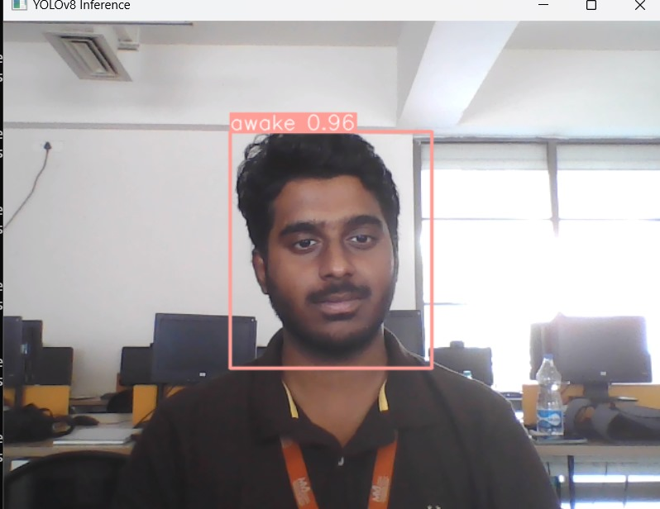

Fig 6.4 P 2 Drowsy.

Fig 6.3 P 2 Awake.

In the above figure 6.3 & 6.4 The system identifies Person 2 Awake in 6.3 and Drowsy in 6.4

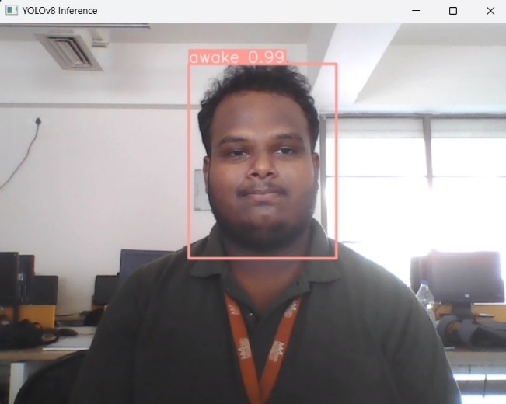

Fig 6.5 P 3 Awake.

Fig 6.6 P 3 Drowsy.

In the above figure 6.5 & 6.6 The system identifies Person 3 Awake in 6.5 and Drowsy in 6.6

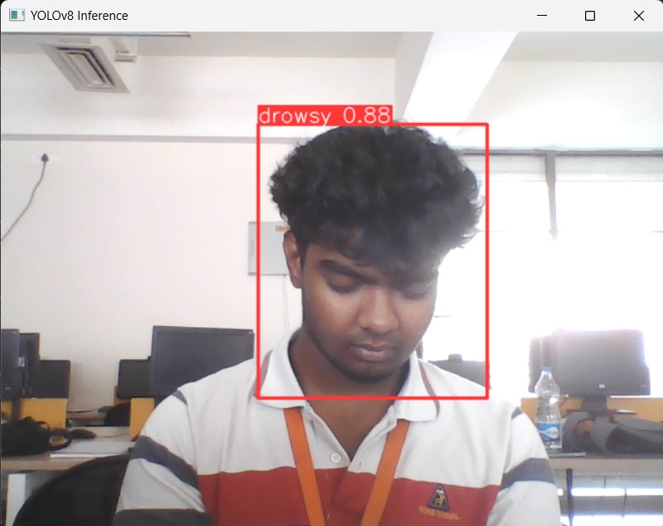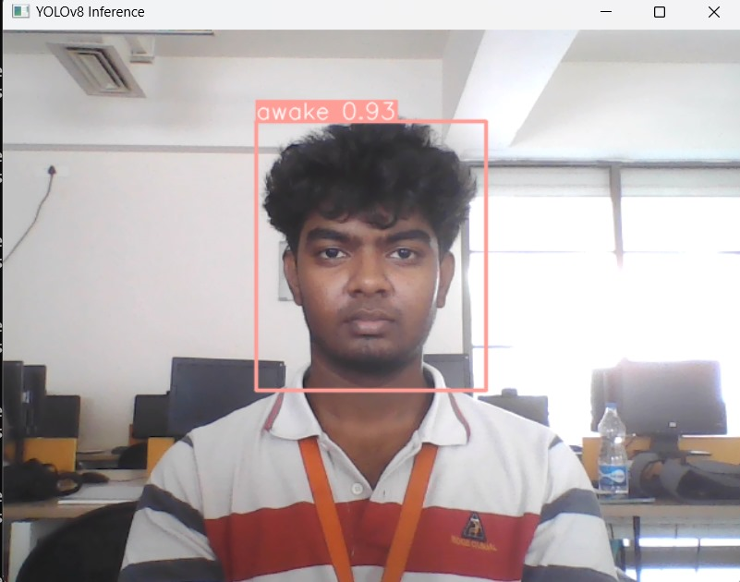

Fig 6.8 P 4 Drowsy.

Fig 6.7 P 4 Awake.

In the above figure 6.7 & 6.8 The system identifies Person 4 Awake in 6.7 and Drowsy in 6.8

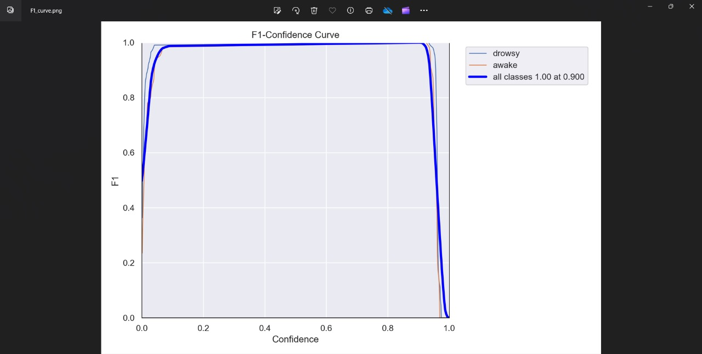

Fig 6.9 Confidence Curve

Fig 6.10 Confusion Matrix

The above figures 6.9 shows the Confidence Curve obtained in this model & The figure 6.10 shows the Confusion Matrix.

***CHAPTER-7***

***REQUIREMENTS***

**CHAPTER 7**

**REQUIREMENTS**

**7.1. Functional Requirements**

* **Live Image Capture:** The system must capture live images of the driver's face through a webcam installed in the vehicle.
* **YOLOv8 Integration:** Integrate the YOLOv8 model to perform real-time object detection on the captured images, focusing on facial features indicative of drowsiness.
* **Preprocessing Module:** Develop a preprocessing module to resize, normalize, and enhance images for optimal input to the YOLOv8 model.
* **Drowsiness Detection Logic:** Implement algorithms to interpret the YOLOv8 output, identifying patterns related to drowsiness, such as facial expressions and eye movements.
* **Alerting Mechanism:** Integrate an alerting mechanism, such as a buzzer, to notify the driver in real-time when signs of drowsiness are detected.

**7.2. Non-Functional Requirements**

* **Performance:** The system should process images and detect drowsiness within milliseconds to ensure real-time responsiveness.
* **Accuracy:** The drowsiness detection system must achieve a high level of accuracy in identifying signs of drowsiness to minimize false positives and negatives.
* **Scalability:** The system should be designed to scale, accommodating different vehicle models and varying hardware specifications.
* **Security:** Implement security measures to protect user privacy and prevent unauthorized access to the system or stored data.

**7.3.** **Software Requirements**

* Programming Language – Python
* Operating System – Windows or Linux
* OpenCV (Open-Source Computer Vision): Used for capturing live images from the webcam, image preprocessing, and interfacing with the YOLOv8 model for object detection.
* YOLOv8 (You Only Look Once version 8): The YOLOv8 model itself, integrated into the project for real-time object detection, specifically to identify signs of drowsiness in facial features.
* NumPy: Utilized for numerical operations and array manipulation, especially in the context of image processing tasks.
* TensorFlow or PyTorch: Chosen as the deep learning framework to work with the YOLOv8 model, enabling integration, training (if necessary), and inference.
* Dlib: Potentially used for facial landmark detection, extracting detailed facial features for more sophisticated analysis.

**7.4. Hardware Requirements**

* Dlib Controller

# 1080P HD Digital Webcam with Built-in Mic, Plug and Play Setup

* Sound device (Buzzer)

***CHAPTER-8***

***CONCLUSION***

**CONCLUSION**

In this project, we have used YOLO (You Look Only Once) v8 object detection system to train dataset and after training we can use this model to detect and monitor the driver whether he is drowsy or in awaken state.

If the driver is feeling drowsy then an alarm sound will be generated.

This model has successfully detected both classes (drowsy and awake) as mentioned in the dataset and successfully detected and monitored the driver’s state.

***REFERENCES***

**References**

[1] H. Lou, X. Duan, and J. Guo, "The Small Size Object Detection Algorithm Based on Camera Sensor," in *Proceedings of the IEEE International Conference on Computer Vision*, 2023.

[2] T. Wu and Y. Dong, "Improved YOLOv8 for Remote Sensing Object Detection," in *Proceedings of the IEEE International Conference on Computer Vision*, 2023.

[3] G. S., N. Duraimurugan, and S. P. Chokkalingam, "Real-Time Object Detection with YOLO," in *Proceedings of the IEEE International Conference on Computer Vision*, 2019.

[4] J. Redmon, "Unified, Real-Time Object Detection," in *Proceedings of the IEEE International Conference on Computer Vision*, 2020.

[5] M. Gasti and P. Das, "A Review on Face Recognition Systems Built Using YOLO," in *Proceedings of the IEEE International Conference on Computer Vision*, 2021.

[6] G. Lavanya and S. D. Pande, "Enhancing Real-Time Object Detection with YOLO Algorithm," in *Proceedings of the IEEE International Conference on Computer Vision*, 2023.

[7] N. Dewantoro, P. N. Fernando, and S. Tan, "YOLO Algorithm Accuracy Analysis in Detecting Number of Vehicles at the Intersection," in *Proceedings of the IEEE International Conference on Computer Vision*, 2023.

[8] A. Marode, "Car Detection Using YOLO Algorithm," in *Proceedings of the IEEE International Conference on Computer Vision*, 2021.

[9] S. Titare and S. Chinchghare, "Driver Drowsiness Detection and Alert System," in *Proceedings of the IEEE International Conference on Computer Vision*, 2021.

[10] X. Hu and G. Lodewijks, "Detecting Fatigue in Car Drivers and Aircraft Pilots by Using Non-Invasive Measures," in *Proceedings of the IEEE International Conference on Computer Vision*, 2020.